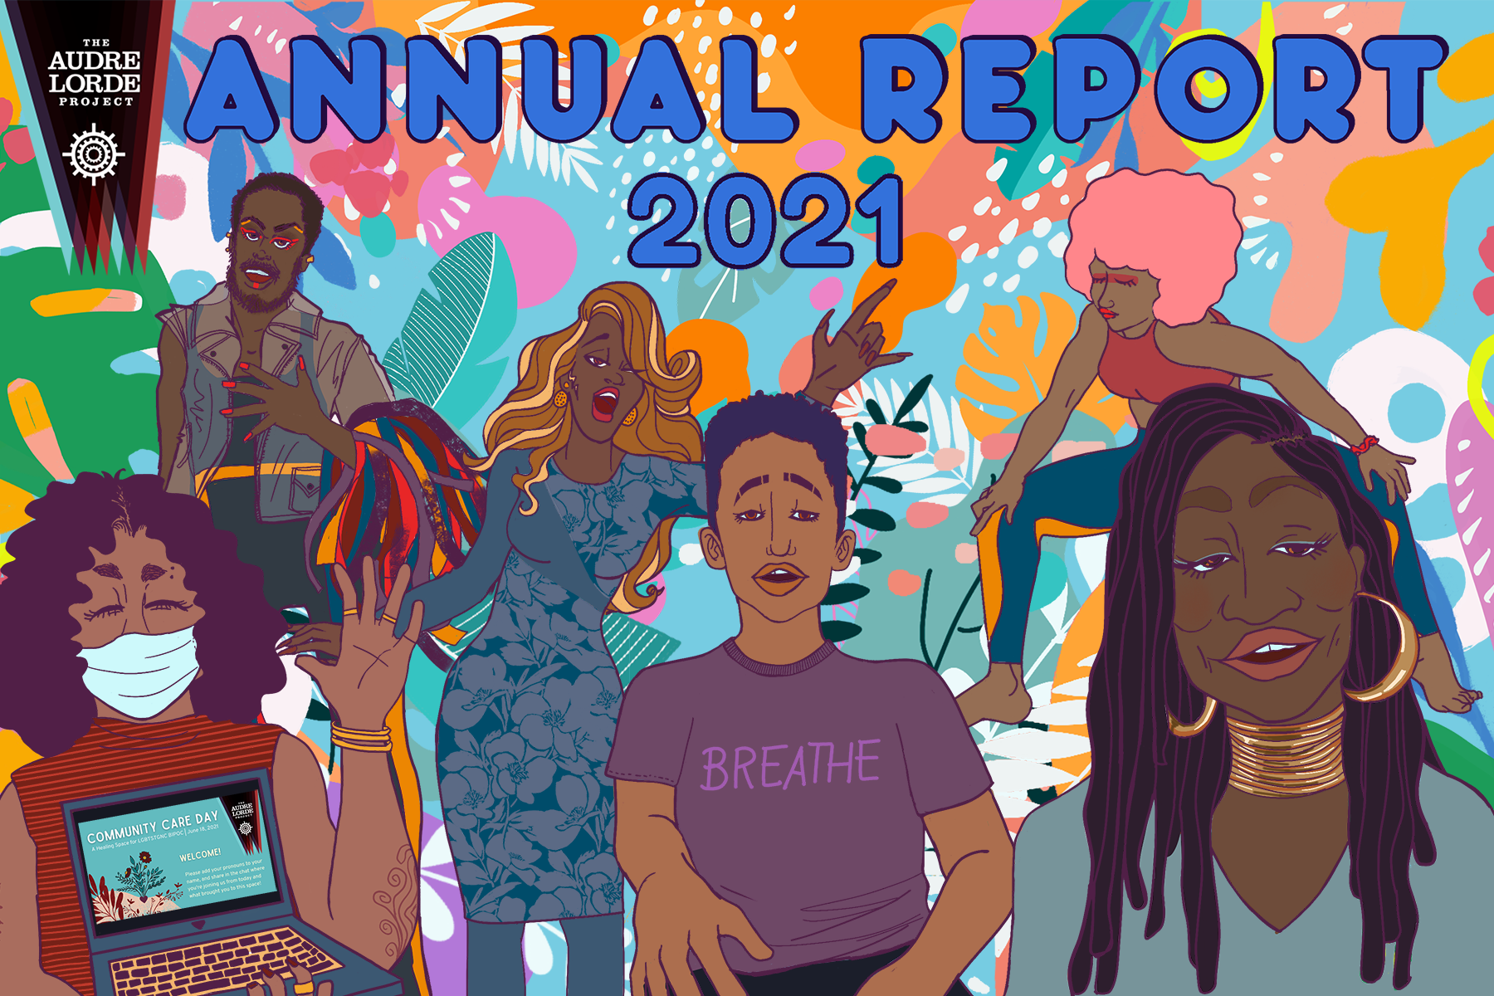

Image Description: An illustrated collage of Audre Lorde Project members at various events throughout the 2021 calendar year. The collage includes illustrations of queer and trans people of color dancing, singing, and smiling. On the bottom left there is an illustration of a person waving and holding a laptop screen with the words “Community Care Day” on the screen. Near the center, there is an illustration of an ALP member wearing a purple shirt with the word “breathe” across the center. At the top of the illustration are the words “Annual Report 2021” in big, bold blue letters. The Audre Lorde Project logo is in the upper left hand corner. Credit: Acacia Rodriguez.

Annual Report 2021: The Year We Moved at the Pace of Trust

Audio Reflection Transcripts

Flexible: Kerbie Joseph. Pronouns, she, her/them, they. Safe Outside the System coordinator at the Audre Lorde Project. If I can describe ALP, within this past year, I would say, flexible. Within this past year, we shifted so much of our work, our energy into making sure that our community members and our community can not only survive, but thrive. Our work plans have shifted to make sure that we're uplifting outreach and connecting with our members. It shifted to make sure that we're doing coalition work for our greater members that aren't in our constituency. We have made room to grieve our leadership transitions, we have made room for self care, and the care of each other as a staff. And we have been flexible in lifting our concerns and our fears in a way that made it possible for us to communicate those same fears, but also create resolutions, and also communicate those resolutions to our members. Even though we fight for liberation every day, and we fight to organize our comrades in our communities – some of the most marginalized people in this world – we always were able to shift and be flexible enough and thoughtful enough to allow room to breathe to make those shifts. And that's what it means to be an organizer. You always have to be flexible, as the key to being accessible. And I think ALP this year has really gotten a grip on that. And it shows in our work, how we have been retaining our members and being so thoughtful and how we are organizing our campaigns in the future. So happy one year to this year, and on to the next year with more flexibility.

Transitional: Hello, my name is Marley. My pronouns are she/they, I am a member of ALP (The Audre Lorde Project) and have worked on various projects with the organization. Most recently, this involves joining the Third Space Rapid Response Team. And if I had to describe the last year with ALP, in one word, I'd say transitional. The Audre Lorde Project has had to go through many transitions, just like all of us have this past year. And really, these past two years. We're all trying to figure out how to adjust and adapt to this pandemic life. And there have also been some transitions among leadership and other things. So I think it's just been a time, a big time for learning, and growing together and collaborating with each other. And I think it's really offered us the time to turn inward and reflect on both the work we do and the work we want to be doing. I find transitions to be hard sometimes. But I think going through a transitional time with a community, within community is a really beautiful thing in many ways. And I think I've definitely seen that this past year, and I think we are coming out very strong. I've really been blessed and happy to be a part of this time with ALP.

Safety: My name is Indra, my pronouns are she and they and I'm the Third Space program coordinator at ALP. The word that first comes to mind for me when I think about my past year at ALP is safe. I've experienced a lot of feeling unsafe in my life, just like many other folks in our community, unfortunately, we're constantly fighting to survive in a world that's just unsafe for us by design. So living through, you know, capitalism, abuse, and so many other types of violence has just caused so much trauma for our people. And it's really hard to start healing from trauma when you feel like fundamentally unsafe and isolated and are just stuck operating in survival mode all the time. And especially now with this like never-ending pandemic feeling. Safe is harder than ever for our folks. But ALP is really the first organizing space, I think, where I've ever felt like fully safe. Like safe enough to show up as my whole self. And I know that many of our other members feel the same way. Because ALP is like trauma-informed, and accessible. And makes accessibility like really a priority. And thinks about healing. Our collective trauma is like a really crucial part of the work we're doing. So because of that I feel totally safe, being transparent about, you know, being disabled, having a chronic illness, and having PTSD. And I'm able to just advocate for my needs, knowing that I'll be heard and respected and like thoughtfully, accommodated, instead of being invalidated and dismissed, like I have been so many times before in other places. And feeling safe at ALP, you know, has also helped me to just like get out of my comfort zone and start testing out my strengths as a leader. Like my whole life I feel like I've held myself back because I've been so afraid to mess up in even the smallest ways. Like even just like being afraid of confirming somebody's preconceived notion, or preconceived ideas about me because of my identities. But here I hardly ever feel like that same kind of fear of making mistakes anymore because I know that this community believes in transformation. And I know that we're all here to support each other and learning and just doing better every time. And honestly, the amazing thing about it is how much this has increased my confidence and self worth even outside of ALP. You know, just knowing that like, the way I feel here at ALP is the way I should be able to feel everywhere. But yeah, the feeling of safe like being safe at ALP and the care and the nurturing that, you know, I've experienced, just like giving and receiving, has really laid the foundation for me to just heal and have so much personal growth. And the best part of that is just being able to continue to be in these spaces to pass that along to other members. And know that all of us are then taking this healing back to our own pods and our own loved ones. And, like it's really beautiful to see how the work we do here continues to just ripple outwards. Yeah, so I'm just very grateful to be a part of this amazing community.

Discovery: Hi, my name is Anqa Khan, my pronouns are they and them. I'm the member engagement coordinator at the Audre Lorde Project. And if I could describe the last year at ALP, with one word, it would be discovery. I feel like this last year there has been a lot of ALP discovering itself. You know, folks discovering the organization, again. Coming back to it after a restoration period. ALP discovering what the niche is and what the role ALP can specifically play in movement in New York City, in the housing justice struggle in New York City, and as a home specifically, and an organizing home specifically for queer and trans people of color. I think there has been a lot of renewal in discovering what the you know, goals of ALP are and how we want to connect that to people's material needs, how folks have been doing throughout this, and, you know, massive moment of crisis, and discovering new ways to support. New ways to educate, returning, and discovering the ways that we used to do things and figuring out what might work again, and what can work. And we can shift I think in a different way. So discovery, and re-discovery, I think is the name of the game this past year.

Openness: So I'm Rumi Akong. Pronouns are they and he, and I'm the Trans Justice coordinator at the Audre Lorde Project. I think I would use the word open, and I would say opening is a good word because I think it's reflective, reflective, especially of our folks’ experiences. Our members are moving into these new realities and how that's impacted their access to the organization. And this past year, I would say there has been so much evidence of our community members extending and like broadening their scope of what they understand is possible in community organizing.

Reliance: Cleopatra Acquaye-Reynolds. My pronouns are sir and her and I am the co-director of Audre Lorde Project. If I could describe lp in one word, the word I would use is finally, because it feels like we have found a groove, that relies on us relying on each other. And everyone acknowledges that they rely on each other. And that's a really good place to be in I feel.

Growth: I'm Maxwell Scales, my pronouns are he/him, they/them. And I'm the co-director of the Audre Lorde Project. I think my word would just be growth, because in the past year the staff has gone from five to nine people, our budget has increased. We've seen a lot of new members enter the organization. So even though it has been, you know, a really difficult year, our folks have found a way to really thrive and grow.

Elevation: My name is India Harris, and my pronouns are she/her/hers. And I am currently the Deputy Director of the Audre Lorde Project. If I had to describe the last year of 2021 at the Audre Lorde Project, with one word, the word would be elevation. We are tasked with the work of elevation. And that is the upliftment of ourselves and our spirits and the upliftment of the spirits and the well being of our community. Our community being lesbian, gay, bisexual, trans, gender, non conforming to spirit, people of color in New York City. Elevation requires us to lean into deeper vulnerability and requires us to move into the unknown. And that is very much the work of the world, in 2020, and 2021, is to move into the unknown. Holding everything close that we value, and a sense of integrity, and a sense of wrestling with the question of what serves the well being of the collective as opposed to what serves any of our interests. As an individual I have been called to elevate my understanding of what the work has been since I've been a member of the Audre Lorde Project over the last 12 years. To be backwards-facing while also being forward-facing, right? And looking into the future, the future of our communities in New York City, the future that has us growing and thriving and creating out of a sense of joy and a sense of purposefulness, and a sense of connection. Connection is what has gotten us to this point and what has really given deep meaning to all the work that we've done. Our connection to our members, our connection to one another, connection to all the forces that are seen and unseen. And we are tasked, called, expected to take our place and in taking our place, to elevate all that has been and all that will be.

Rooting: My name is Danya, I'm the Grassroots Fundraising Coordinator at the Audre Lorde Project. My pronouns are she and they and I would use the word rooting to describe the last year. I feel like we've had to root and reroot ourselves in our mission and our purpose. In what it means to organize community in an ongoing pandemic, and amidst deep structural violence. And I think this last year has really been about being firmly rooted and deepening our roots. And I've definitely seen that since I've joined the team at the Audre Lorde Project in January of 2021. And I think I have seen a lot of that this year, at all levels and at all corners of the organization. And I'm looking forward to seeing more of that in this next year because the thing about rooting and rerooting yourself is your roots can only get deeper and the deeper your roots are, the more sturdy and sort of more grounded, you become.

For any questions, please contact Danya AbdelHameid, Grassroots Fundraising Coordinator, danya@alp.org.

